Artificial Intelligence for Games

*A.I. Brief*

**Basic Description**

You play as Sgt Dude and you are sent of a sneak mission to steal the weapons from the evil aliens without being spotted.

* You will be placed into a level with multiple rooms, scattered with enemies and you goal will be to collect as many of the objectives as possible without being spotted or killed by the enemy AI (Aliens).
* If you are spotted (within an enemy’s cone of vision), the enemy will chase you down and if caught, you are killed and the game ends.
* If you are spotted by an enemy, and escape their cone of sight, they will enter a state of increased alertness in which they are will wander faster and stay around the area they last saw you.

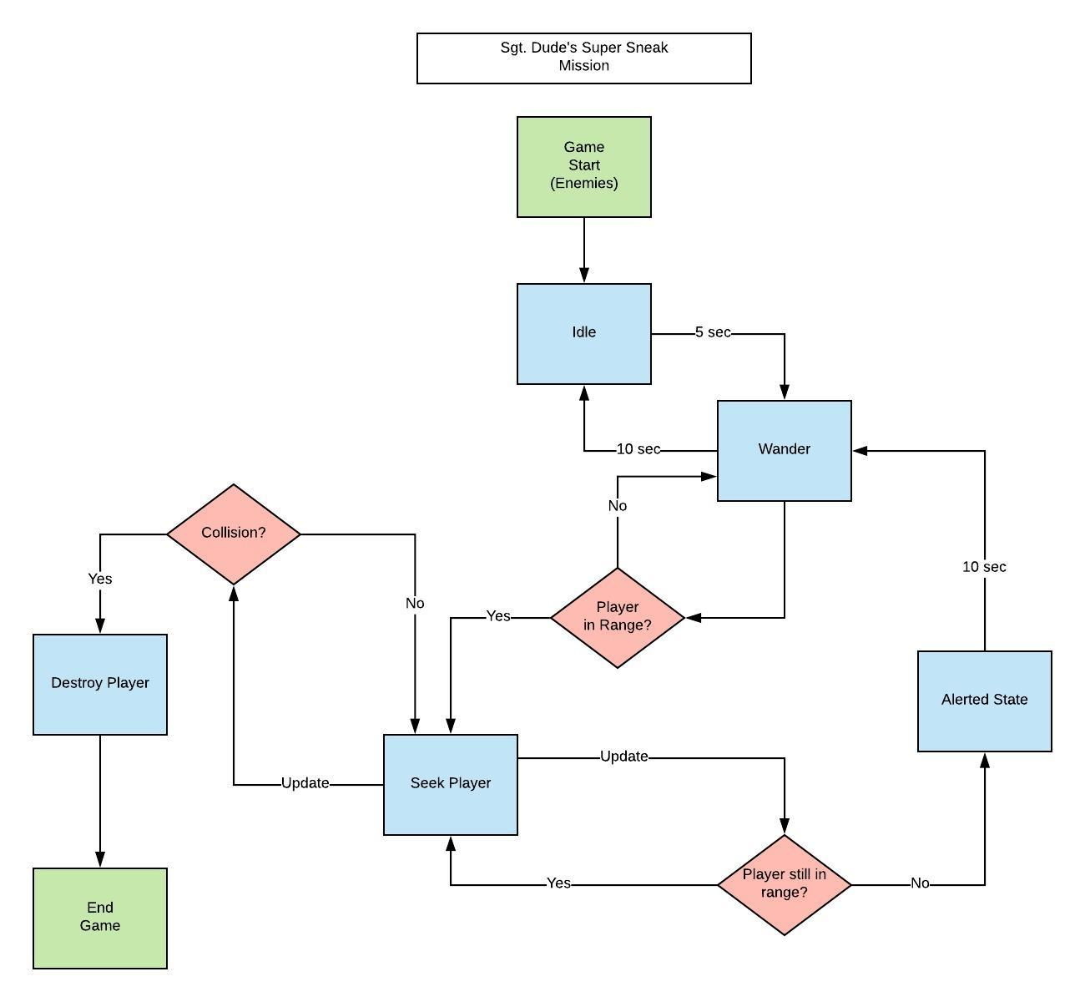

**AI Mechanics:**

* The game will make use of Finite State Machines to switch between active states in the AI (e.g. The AI will transition from a stage of wandering to seeking the player if the player moves into the AI’s cone of sight).
* The AI will use a A* method of pathfinding for when it is in its seeking state.

***Amendments****:*

* *Game does not have multiple rooms*
* *Enemy AI do not have an alerted state, meaning they will only alternate between chasing and wandering*
* *A* is not used for most enemies, although is used by one AI object to path find to a random point in the grid*